- Submit 1-2 screenshots of your project progress.
  - 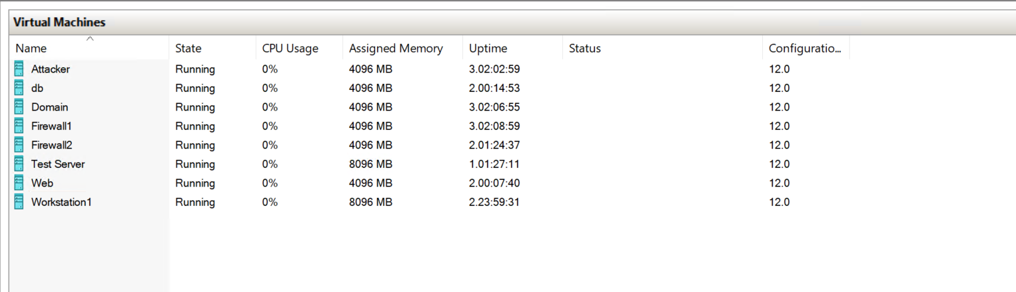
  - 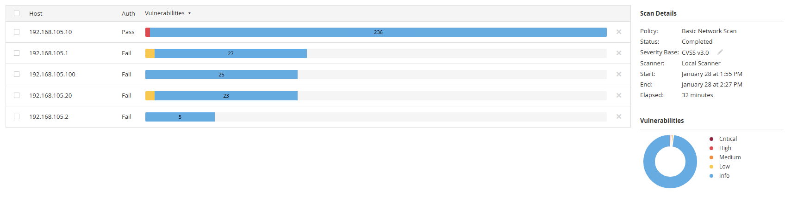
- Self-evaluation survey (including hours, moods, and notes).
  - Hours:
    - H:76
    - M:36
  - Mood:
    - Stressed But feeling like everything’s working out now
  - Notes:
    - Only thing of note is that setup and configuration has taken longer than expected due to migration and other errors.
- Provide a screenshot or link showing your recent GitHub activity from the past 2 days.
  - 